18U ENCLOSURE 19" CABINET 600X600 18U FLOOR STANDING CABINET
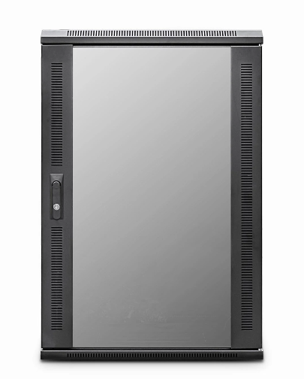

DESCRIPTION
Redefining quality ergonomics for your telco, networking & PBX needs
Cost-effective and quality 18U Floor Standing Cabinet /enclosures for your structured cabling, networking and
broadcast projects.
The LMS Data EcoNetCab is the de-fecto standard in offering great choice
and quality18U Floor Standing Cabinet/ enclosure solutions, be it structured cabling for your copper or
fibre networking, LAN or WAN networking deployment or broadcast A/V for companies of all sizes.
Designed for the installer and IT manager, all enclosures come with useful features to make your installation that much easier, together with bundled free accessories you need to get your new installation up an running, with minimal fuss or downtime.

SPECIFICATIONS
18U high 600W 600D
ETSI 19" front/rear profiles (adjustable)
Removable side/rear panels, RAL 9005
Front tempered glass door (lockable)

TECHNICAL INFO
SKU/MPN: CAB-FE-18U-66
EAN: 8400800028044
Weight: 50Kg
Dimensions: 600(width) x 600(depth) x 980mm(height)

FILES
Datasheet - CAB-FE-18U-66

